AquaChain Opportunity Pitch Report
Team 1 Mihir Kavishwar, Shruti Kalyanaraman, Rachana Bangalore Nagaraju, Patrick Okimi, William Lopez
Department of Industrial and Systems Engineering
University of Southern California
ISE 585 Strategic Management of Technology and Innovation, Spring 2024
Instructor Paul Lu
Due Date Apr 26, 2024

Vision and Value Proposition byMihir Kavishwar

Vision for AquaChain
AquaChain envisions a world where every individual has access to clean and safe water, contributing to global sustainability.

Value Proposition for AquaChain
AquaChain secures transparent water management for sustainable communities.
AquaChain's value proposition lies in its blockchain-powered water management system, revolutionizing how water resources are monitored, managed, and distributed. By providing real-time monitoring, enhanced security, and transparent data sharing, AquaChain ensures efficient and sustainable water usage for municipalities, utilities, and regulatory agencies. Our solution not only addresses fundamental human needs but also empowers communities to safeguard their water resources for future generations.

The problem explained byWilliam Lopez
- Contamination aging infrastructure, human activities such as illegal dumping and sewage spills
- In 2021, reported violations involving water treatment rules were responsible for exceeding health-based standards for 15.6 million people

The Crisis
- Aging water infrastructure is failing, leading to leaks and potential contamination.
- Fragmented data management hinders the timely detection of issues and swift response.
- Growing cybersecurity threats put critical water infrastructure at risk of manipulation.

The Health Impact
- Contaminated water can cause serious health problems, including
  - Gastrointestinal illnesses (diarrhea, vomiting)
  - Skin infections
  - Chemical poisoning
  - Waterborne diseases (cholera, typhoid)

The solution byMihir Kavishwar
Our solution leverages Blockchain technology to revolutionize water supply management, offering transparency, efficiency, and security in water distribution and consumption. By integrating Blockchain into the water supply infrastructure, we address key challenges faced by utilities, municipalities, and consumers, ensuring sustainable and reliable access to clean water.

Transparency and Traceability
Blockchain technology enables transparent and immutable recording of water transactions, from production to distribution to consumption.

Efficient Resource Allocation
Smart contracts deployed on the Blockchain automate water allocation, optimizing resource utilization based on real-time demand and supply data.

Real-Time Monitoring and Management
IoT sensors integrated with the Blockchain enable real-time monitoring of water quality, pressure, and usage levels across the distribution network.

Secure Data Sharing and Collaboration
Blockchain-based platforms facilitate secure data sharing and collaboration among stakeholders, including utilities, regulators, consumers, and third-party service providers.

Benefits

Improved Efficiency
Streamlined water management processes and automated workflows reduce operational costs and improve efficiency.

Enhanced Transparency
Transparent and auditable water transactions foster trust among stakeholders and enable better governance of water.

Sustainable Practices
Data-driven insights and proactive monitoring enable utilities to implement sustainable water conservation measures.

Resilient Infrastructure
Real-time monitoring and response capabilities enhance the resilience of water supply infrastructure, mitigating risks and ensuring uninterrupted service delivery.

Product, Service, Features and Functions byShruti Kalyanaraman

Features
- Decentralized Blockchain Network AquaChain operates on a decentralized blockchain network, ensuring transparency and security of data related to water supply management.
- Sensor Integration AquaChain integrates with cutting-edge sensors from partner companies to collect real-time data on various parameters such as water quality, flow rates, temperature, and pressure.
- Smart Contracts Utilizes smart contracts to automate agreements between different stakeholders in the water supply chain, ensuring compliance with regulations.
- User Interface (UI) Provides a user-friendly interface for stakeholders to access and interact with the blockchain-based management system, facilitating monitoring, tracking, and analysis of water-related data.
- Data Analytics Module Includes a robust data analytics module that allows users to perform a comprehensive analysis of data stored on the blockchain, enabling the identification of various trends.
- IoT Integration Seamlessly integrates with Internet of Things (IoT) devices and sensors deployed throughout the water supply chain, enhancing data collection and monitoring capabilities.

Functions
- Record Keeping AquaChain securely records every step in the water supply chain, including the source of water, quality assessments, distribution routes, and consumption data.
- Transparency Provides transparent access to water-related data stored on the blockchain, fostering trust among stakeholders and ensuring accountability in managing water resources.
- Automation Utilizes smart contracts to automate billing and payments, reducing manual intervention and minimizing the risk of errors.
- Real-time Monitoring Enables real-time monitoring of water quality, flow rates, and other parameters through integration with sensors, allowing for timely interventions.
- Compliance Assurance Ensures compliance with regulatory standards through the enforcement of smart contracts and the transparent recording of data on the blockchain.

The Market byRachana Bangalore Nagaraju
Market Reach and Distribution (Where will the product/service be sold)
AquaChain's product/service will be sold initially in Southern California's water management market, with plans for expansion into other regions of the United States and eventually global markets

Target Customer Base
- Total Addressable Market (TAM) AquaChain's TAM includes all entities involved in water management, such as utility companies, municipalities, water management organizations, and regulatory agencies, both in Southern California and globally.
- Serviceable Addressable Market (SAM) Within the TAM, AquaChain focuses on the water management market in specific regions. SAM focuses on new territories like other states in the United States apart from Southern California.
- Serviceable Obtainable Market (SOM) SOM for AquaChain is Southern California within the United States.

Market Size & Revenue Generation Strategy
Market Size_Revenue Potential Please find the attached documents that encompass market size and revenue generation strategy.

Competition and Risk byRachana Bangalore Nagaraju

Competition Analysis
AquaChain does not have direct competitors offering a full-fledged blockchain-based water management system with integrated sensors.Competitors with SWOTThe document showcases the Competition analysis with strengths and weaknesses along with the graphical analysis.

Customer
Customer Names and Revenue_YTDPlease find the attached list of the top 10 customers for the past three fiscal years and the current YTD with revenue.Customer Relationship_Infooutlines significant customer relationships and information.

Competition Strategies
Aquachain's Competitive StrategiesShowcases the detailed competition strategies and Aquachain’s competitive benefits that will help us beat the competition.

Risk Management
Aquachain's Risk ManagementThis explains the detailed risk analysis and management with Impact and Mitigation strategies.

Revenue and Operating Cost Mihir Kavishwar
The revenue operating costs and profits are projected in the graph below. To access the graph refer to bookmark:AquaChain: Opportunity Pitch Report. The detailed operating costs are given in the commercialization overview document as follows. Team1: Overview of Commercialization
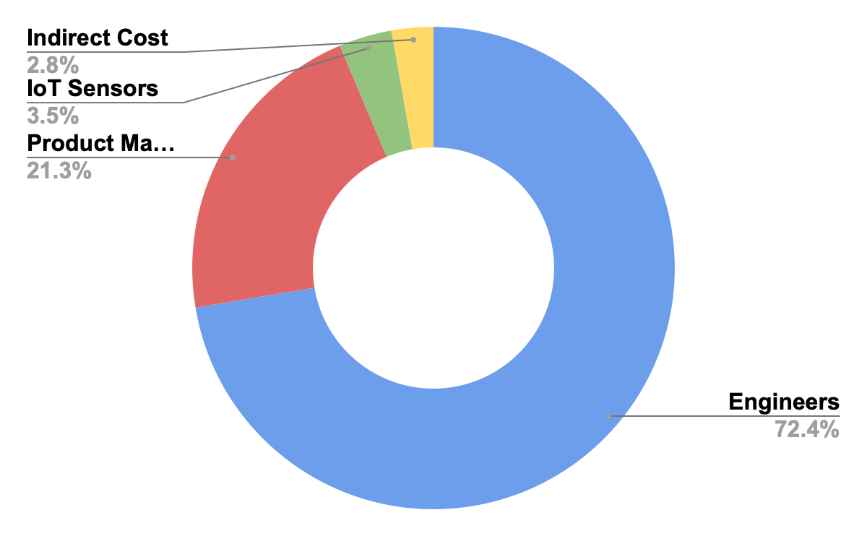

Traction byWilliam Lopez
Blockchain technology is a driver of innovation. The blockchain market possesses a market compound growth rate of 66%. In addition, billions of dollars have been invested to develop blockchain solutions to some of the world's most complex problems. It is estimated that blockchain will add over 3 trillion dollars in business value by 2030. Aquachain will not only own the smart water management sector of the blockchain market but will also contribute to reducing water waste by households in the United States which is on the order of hundreds of billions of gallons each year. Overall, Aquchain will not only ensure water usage is more efficient but that the quality of water is also increased in order to prevent future occurrences of water contamination such as the Flint, Michigan water crisis which occurred just 10 years ago in 2014.

Projections byPatrick Okimi
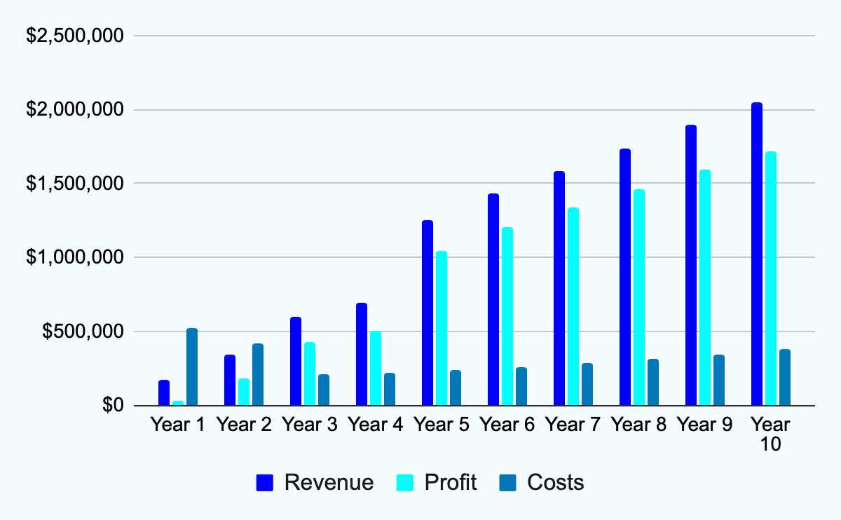
AquaChain's long-term success is underpinned by robust financial projections and strategic planning. With a forecasted 83% gross profit margin by year 5 and an impressive 122% return on investment over a decade, AquaChain demonstrates promising financial viability. Projections indicate a substantial $6 million EBITDA over 10 years, fueled by a projected revenue of $11 million within the same timeframe. Furthermore, the compound annual growth rate (CAGR) for water management systems stands at a solid 13% over 10 years, reflecting sustained market demand and AquaChain's anticipated growth trajectory ( Global Water Management Systems Market Size, Forecast to 2033sphericalinsights·1).
Considering revenue, profit, and costs over the course of 10 years, AquaChain's financial model outlines a steady increase in net sales, starting from $174,480 in year 1 and reaching $2,048,340.68 by year 10. Despite rising costs of revenue, including sales expenses, AquaChain maintains a healthy gross profit, with year 5 grossing over $1 million. Operating expenses, primarily attributed to research and development as well as other operational costs, are carefully managed. AquaChain anticipates achieving operating income from year 3 onwards, with substantial gains projected by year 5. A graph providing AquaChains revenue, profit, and costs is linked and provided.

Additional references to the provided information can be found here Team1: Overview of Commercialization

The Team byPatrick Okimi
Name | Position | Strengths
Mihir Kavishwar | CFO | - IoT and Electronics Engineer  - Software Engineering  - Financial Modelling
William Lopez | COO | - Operations Leader in the Aerospace Industry  - Mechanical Engineering Background
Shruti Kalyanaraman | CPO | - Product Management  - Decision Making  - Market & Customer Insights
Rachana Bangalore Nagaraju | CMO | -Technical Expertise  -Marketing Savvy  -Energy Industry Experience
Patrick Okimi | CEO | -Hardware Product developer  - Mechanical Engineer at Heart  - Consumer Goods Background
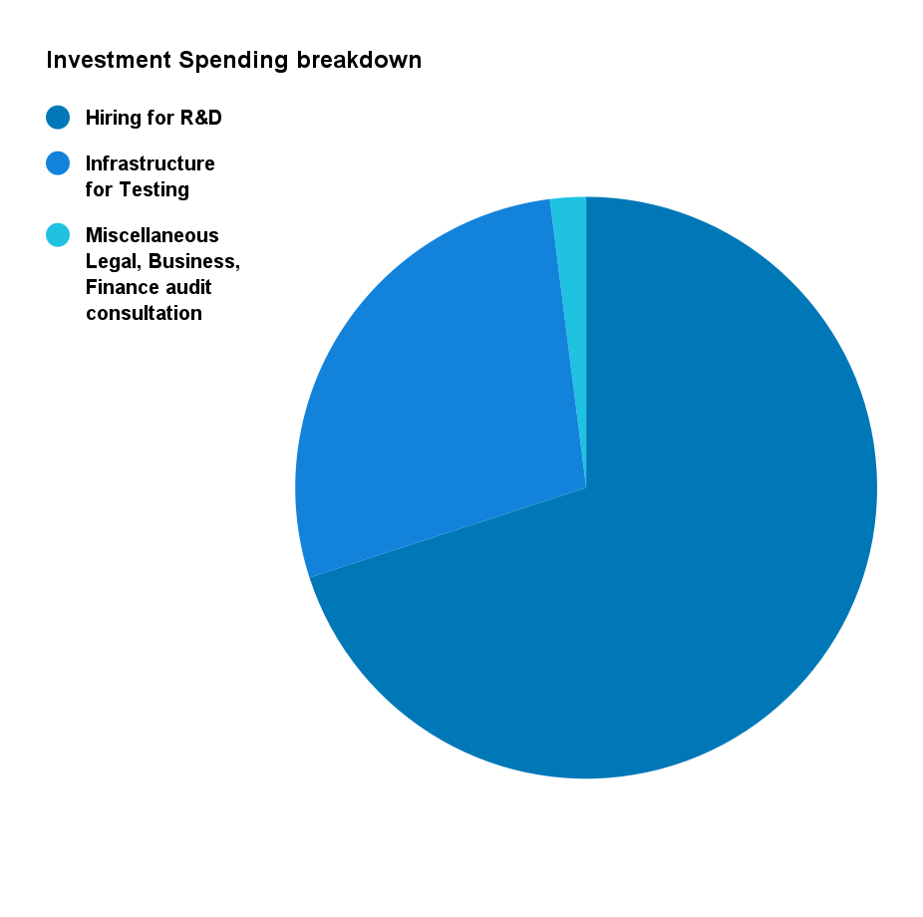

The Ask byMihir Kavishwar

Valuation
Our ask is $3M for 5% equity of our company. Please refer to the valuation details from Team1: Overview of Commercialization.
Most of the investment spending will be done on hiring people for initial non-recurring research and development. About 28% would be used for testing and technical support. The remaining 2% would be used for Legal, Financial, and business consulting fees.

Breakdown
Hiring for R&D | 70%
Infrastructure for Testing | 28%
Miscellaneous Legal, Business, Finance audit consultation | 2%

